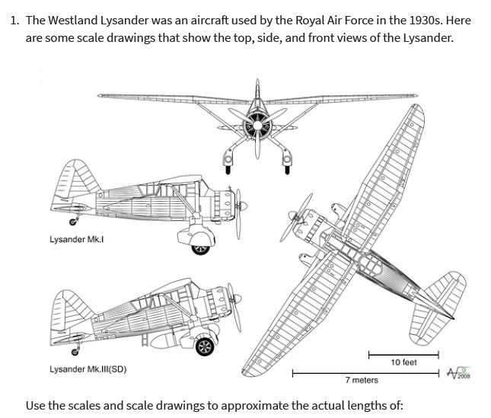
- the wingspan of the plane, to the nearest foot

- the height of the plane, to the nearest foot

- the length of the Lysander Mk. I, to the nearest meter

